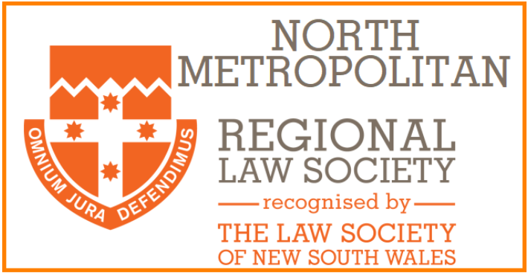

Dear Colleagues,
Happy New Year 2023!

Some of you will know me from our regular monthly newsletters. To the rest of you … I would like to take this opportunity to welcome you to our regional law society, North Metropolitan. A little bit about us …

We hold 10 monthly dinner meetings between February and November – 8 of them have speakers so that you tick off some of that mandatory CPD, one allows you to meet the President and CEO of the Law Society of NSW, and the final dinner is our Christmas gala, held at the Royal Sydney Yacht Squadron in Kirribilli, with arguably the best buffet dinner in town! We’re in the early stages of arranging our first half-day CPD and we’ll share those details as soon as we can.

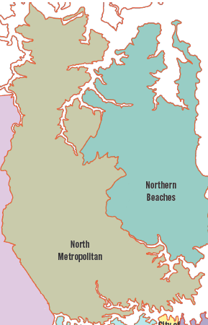
Who are we? If you live or work anywhere between North Sydney and the Hawkesbury, west to Ryde and east to the Roseville Bridge, you are welcome to join us as a member, and if you are outside the region ... then you are still welcome to come as our guest.

We are so happy to be back to face-to-face meetings and we welcome you to join us at our meetings on the last Tuesday of every month (except April which will be a week earlier because of Anzac Day) and I hope this will be permanently etched in your diary.

Who is the committee this year? Here is a little snapshot from our AGM. We are (from left to right): Chris Alchian - Student Liaison Representative, Lauren Absalom – Vice President, Brenton McIntyre – Treasurer, me – your Pres, Edwina Chappel – Young Lawyer Regional Delegate, Tara Jain – Secretary, Lin Zhang and Deborah Ens – General Committee. We’re a varied bunch in age, firm size, specialty and years of practice but what we all have in common is enthusiasm for our branch and a bit of a chinwag.
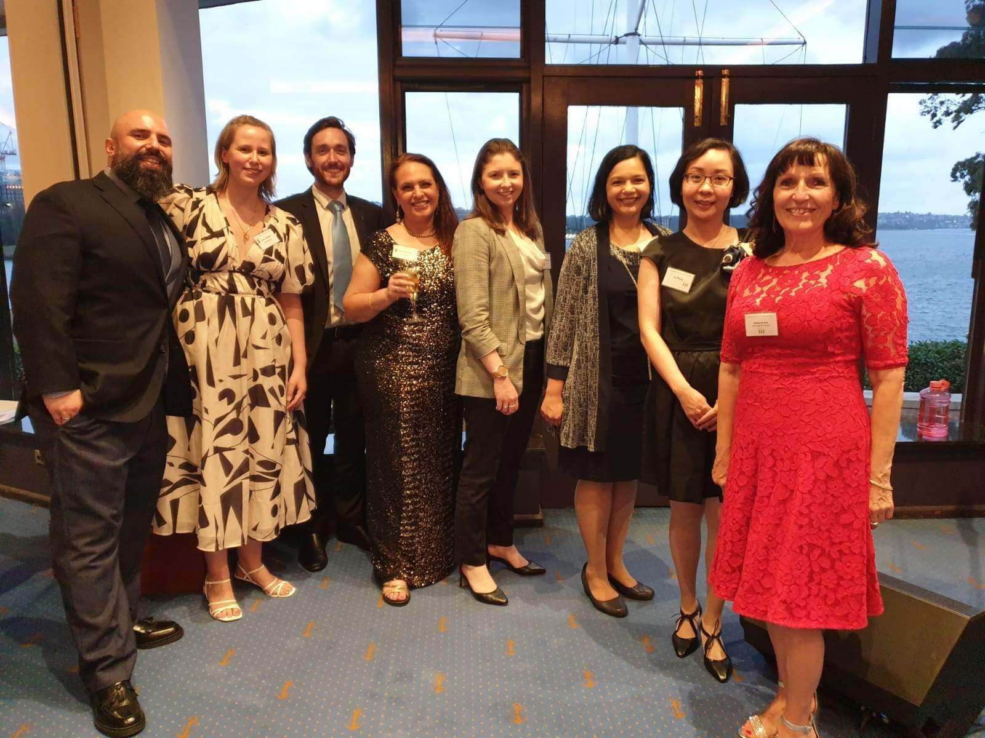
Our calendar for the year …
Date | Event
Tuesday 28 February | Linden Barnes, Senior Ethics Solicitor, The Law Society of NSW  Topic: Ethics
Monday 6 March | Practice Forum
Tuesday 28 March | Susan Hill, Lawyer Accelerator  Topic: 3 steps for accelerating legal skills for new lawyers
Tuesday 18 April | Cassandra Banks, President  Sonja Stewart, CEO  The Law Society of NSW  Topic: Updates on the Profession
Monday 1 May | Practice Forum
Tuesday 30 May | Richard Harvey  Topic: TBC
Tuesday 27 June | Celia Pitcher, Coleman Greig Lawyers  Topic: Family Law
Monday 3 July | Practice Forum
Tuesday 25 July | Tony Cahill TBC  Topic: Property update
Tuesday 29 August | Melissa McGrath, Barrister  Topic: TBC
Monday 4 September | Practice Forum
Tuesday 26 September | Daniel Keserovic, Barrister  Topic: Upcoming (or by the time of the presentation, possibly in force) amendments to the Family Law Act
Tuesday 31 October | The Hon David LLoyd KC  Topic: TBC – land and environment law
Monday 6 November | Practice Forum
Tuesday 28 November | AGM and Christmas Party

You’ll see we have on the calendar 5 entries called “practice forum”. This is an initiative that has been run by our Society for very many years. It is an opportunity for our financial members to get together for an hour and a half after work on a Monday night (same venue as the dinner meetings) and throw around issues and pick the brains of others to get a second opinion on those things you just want to bounce off another colleague.
Thanks to the tireless work of our Vice President, we now have a thriving young lawyer membership. Our young lawyers meet the first Friday evening of each month – please check the Facebook and LinkedIn pages for regular updates.
Yes, we have social media:
Join our Facebook page: https://www.facebook.com/northmetrolawyers
Find us on LinkedIn: https://www.linkedin.com/groups/14023615/
Young Lawyers Facebook: https://www.facebook.com/groups/northmetroyounglawyers
YL LinkedIn: https://www.linkedin.com/groups/7056677/
A link to membership can also be found here: https://www.trybooking.com/CAUDJ
We do plan to have a website however this is still under construction … watch this space.
Finally, I would just like to extend a warm welcome to all lawyers who live and work in our region and an invitation to join as members. Please also join our mailing list so you can have the regular updates in your inbox, alternatively you can check the Regional Societies section of Monday Briefs for details of our monthly meetings.
Thank you for your time and I hope to see you soon.
Warm regards
Sarah Newman
Regional President
North Metropolitan Law Society

